1. Updated E/R diagram

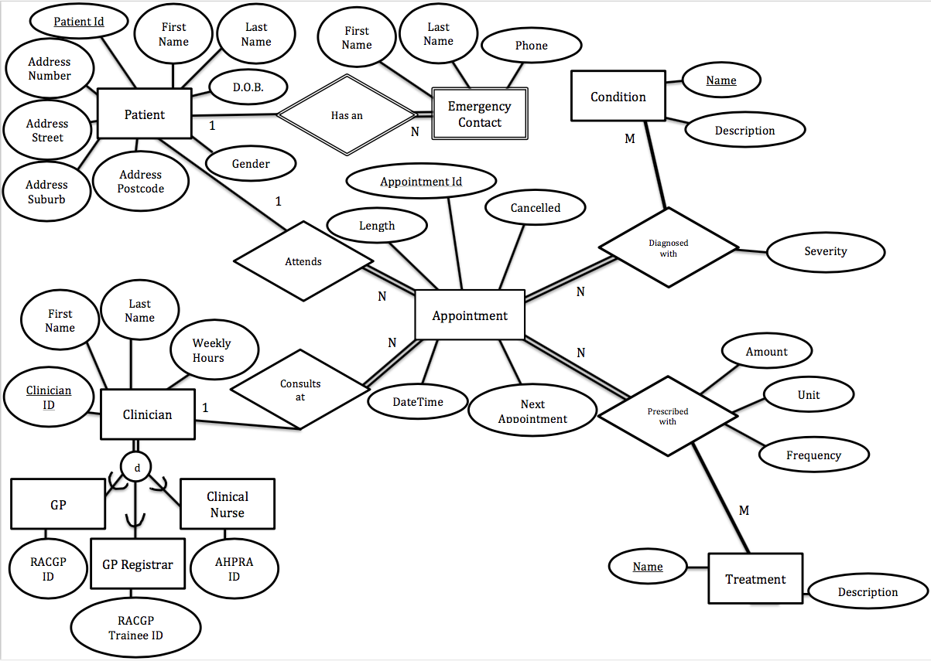

1. Schema

|  |  |  |
| --- | --- | --- |
| **Attribute Name** | **Domain** | **Keys** |
| Table Name: Patient |  |  |
| PatientID | Integer | Key |
| FirstName | String (up to 50 characters) |  |
| LastName | String (up to 50 characters) |  |
| DOB | Date |  |
| Gender | String |  |
| AddressNumber | String (up to 10 characters) |  |
| AddressStreet | String (up to 50 characters) |  |
| AddressSuburb | String (up to 50 characters) |  |
| AddressPostcode | String (up to 10 characters) |  |
| Table Name: Emergency Contact |  |  |
| PatientID | Integer | Foreign Key/Partial Key |
| FirstName | String (up to 50 characters) | Partial Key |
| LastName | String (up to 50 characters) | Partial Key |
| Phone | String (up to 25 characters) |  |
| Table Name: Appointment |  |  |
| AppointmentID | Integer | Key |
| PatientID | Integer | Foreign Key |
| ClinicianID | Integer | Foreign Key |
| AppDateTime | DateTime |  |
| Length | Integer (number of minutes booked for) |  |
| Cancelled | Binary (True or False) |  |
| NextAppointment | DateTime |  |
| Table Name: Clinician |  |  |
| ClinicianID | Integer | Key |
| FirstName | String (up to 50 characters) |  |
| LastName | String (up to 50 characters) |  |
| WeeklyHours | Integer (number of hours rostered to take appointments) |  |
| MedicalRegistrationID | Integer |  |
| MedicalRegistrationIDType | String (RACGP/RACGPTrainee/AHPRA) |  |
| Table Name: Diagnosed |  |  |
| CName | Integer | Foreign Key/Partial Key |
| AppointmentID | Integer | Foreign Key/Partial Key |
| Severity | Integer (scale from 1-10) |  |
| Table Name: Prescription |  |  |
| TName | Integer | Foreign Key/Partial Key |
| AppointmentID | Integer | Foreign Key/Partial Key |
| Amount | Integer (number of units that the patient should take) |  |
| Unit | String (choice of mls/puffs/tablets/other) |  |
| Frequency | String (up to 50 characters) |  |
| Table Name: Conditions |  |  |
| CName | String (up to 50 characters) | Key |
| CDescription | String (up to 250 characters) | Candidate Key |
| Table Name: Treatment |  |  |
| TName | String (up to 50 characters) | Key |
| TDescription | String (up to 250 characters) | Candidate Key |

1. Functional Dependencies

Patient table

* + PatientID -> FirstName, LastName, DOB, Gender, AddressNumber, AddressStreet, AddressSuburb, AddressPostcode
  + *A Patient is uniquely identified by their ID, but Patients may share any other attribute.*

Emergency Contact table

* + PatientID, FirstName, LastName-> Phone
  + *An Emergency Contact is uniquely identified by their full name and the patient they are the contact for, but Emergency Contacts may share a phone number.*

Appointment table

* + AppointmentID -> PatientID, ClinicianID, DateTime, Length, Cancelled, NextAppointment
  + *An Appointment is uniquely identified by its ID, but Appointments may share any other attribute.*

Clinician table

* + ClinicianID -> FirstName, LastName, WeeklyHours, MedicalRegistrationID, MedicalRegistrationIDType
  + *A Clinician is uniquely identified by their ID, but Clinicians may share any other attribute.*

Diagnosed table

* + CName, AppointmentID -> Severity
  + *The severity of a diagnosis is uniquely identified by the condition name (CName) and AppointmentID.*

Prescription table

* + TName, AppointmentID -> Amount, Unit, Frequency
  + *The Amount, Unit and Frequency of a diagnosis is uniquely identified by the treatment name (TName) and Appointment ID.*

Condition table

* + CName -> CDescription
  + CDescription -> CName
  + *The condition name (CName) and condition description (CDescription) uniquely identify each other.*

Treatment table

* + TName -> TDescription
  + TDescription ->TName
  + *The condition name (TName) and condition description (TDescription) uniquely identify each other*.

Candidate keys

All tables except for the Condition and Treatment tables each had only one candidate key which were then used as the primary key. The Condition and Treatment tables had 2 candidate keys but the CName and TName fields were chosen as keys as they are simpler and more consistent.

1. Normalize table
   * Tables are in 3NF
2. SQL script to create tables with primary keys and foreign keys declared

drop table if exists Diagnosed

;

drop table if exists Prescription

;

drop table if exists Appointment

;

drop table if exists Clinician

;

drop table if exists Emergency_contact

;

drop table if exists Patient

;

drop table if exists Conditions

;

drop table if exists Treatment

;

Create Table Patient (

PatientID numeric (6)

,FirstName varchar (50)

,LastName varchar (50)

,DOB date

,Gender varchar (1)

,AddressNumber varchar (10)

,AddressStreet varchar (50)

,AddressSuburb varchar (50)

,AddressPostcode varchar (4)

,PRIMARY KEY (PatientID)

)

;

Create Table Emergency_contact (

PatientID numeric (6)

,FirstName varchar (50)

,LastName varchar (50)

,Phone varchar (25)

,PRIMARY KEY (PatientID, FirstName, LastName)

,Foreign key (PatientID) references Patient (PatientID)

on delete cascade

on update cascade

)

;

Create Table Clinician (

ClinicianID numeric (6)

,FirstName varchar (50)

,LastName varchar (50)

,WeeklyHours numeric (2)

,MedicalRegistrationID numeric (10)

,MedicalRegistrationIDType varchar (12)

,PRIMARY KEY (ClinicianID)

)

;

Create Table Appointment (

AppointmentID numeric (8)

,PatientID numeric (6)

,ClinicianID numeric (6)

,AppDateTime date

,Length numeric (3)

,Cancelled tinyint (2)

,NextAppointment datetime

,PRIMARY KEY (AppointmentID)

,Foreign Key (PatientID) references Patient (PatientID)

on delete restrict

on update cascade

,Foreign Key (ClinicianID) references Clinician (ClinicianID)

on delete restrict

on update cascade

)

;

Create Table Conditions (

ConditionID decimal (4,0)

,CName varchar (50)

,CDescription varchar (250)

,PRIMARY KEY (ConditionID)

)

;

Create Table Treatment (

TreatmentID decimal (4,0)

,TName varchar (50)

,TDescription varchar (250)

,PRIMARY KEY (TreatmentID)

)

;

Create Table Diagnosed (

ConditionID numeric (4)

,AppointmentID numeric (8)

,Severity numeric (2)

,PRIMARY KEY (ConditionID,AppointmentID)

,Foreign key (ConditionID) references Conditions (ConditionID)

on delete restrict

on update cascade

,Foreign Key (AppointmentID) references Appointment (AppointmentID)

on delete restrict

on update cascade

)

;

Create Table Prescription (

TreatmentID varchar (50)

,AppointmentID numeric (8)

,Amount numeric (4)

,Unit varchar (20)

,Frequency varchar (50)

,PRIMARY KEY (TreatmentID,AppointmentID)

,Foreign Key (TreatmentID) references Treatment(TreatmentID)

on delete restrict

on update cascade

,Foreign Key (AppointmentID) references Appointment (AppointmentID)

on delete restrict

on update cascade

)

;

1. Populate 5 tuples in each table

INSERT INTO Patient (PatientID,FirstName,LastName,DOB,Gender,AddressNumber,AddressStreet,AddressSuburb,AddressPostcode) VALUES (1, 'Harriet', 'Timms', '2014-01-01', 'F', 'Unit 9', 'Kappa Rd', 'Northbank', 'N202');

INSERT INTO Patient (PatientID,FirstName,LastName,DOB,Gender,AddressNumber,AddressStreet,AddressSuburb,AddressPostcode) VALUES (2, 'Ernie', 'Quinn', '1929-12-16', 'M', '5', 'Alpha', 'Northbank', 'N101');

INSERT INTO Patient (PatientID,FirstName,LastName,DOB,Gender,AddressNumber,AddressStreet,AddressSuburb,AddressPostcode) VALUES (3, 'Fatima', 'Ranatunga', '1952-06-02', 'F', '6', 'Epsilon', 'Greenhill', 'G111');

INSERT INTO Patient (PatientID,FirstName,LastName,DOB,Gender,AddressNumber,AddressStreet,AddressSuburb,AddressPostcode) VALUES (4, 'Greg', 'Smart', '1979-04-04', 'M', '43319', 'Theta', 'Westlands', 'W259');

INSERT INTO Patient (PatientID,FirstName,LastName,DOB,Gender,AddressNumber,AddressStreet,AddressSuburb,AddressPostcode) VALUES (5, 'Isla', 'Urquhart', '1961-02-21', 'F', '13', 'Lamda Ave', 'Northbank', 'N202');

INSERT INTO Patient (PatientID,FirstName,LastName,DOB,Gender,AddressNumber,AddressStreet,AddressSuburb,AddressPostcode) VALUES (6, 'James', 'Urquhart', '1959-05-14', 'M', '13', 'Lamda Ave', 'Northbank', 'N202');

INSERT INTO Patient (PatientID,FirstName,LastName,DOB,Gender,AddressNumber,AddressStreet,AddressSuburb,AddressPostcode) VALUES (7, 'Kerri', 'Urquhart', '2000-12-25', 'F', '13', 'Lamda Ave', 'Northbank', 'N202');

INSERT INTO Patient (PatientID,FirstName,LastName,DOB,Gender,AddressNumber,AddressStreet,AddressSuburb,AddressPostcode) VALUES (8, 'Liam', 'Urquhart', '2002-04-05', 'M', '13', 'Lamda Ave', 'Northbank', 'N202');

INSERT INTO Emergency_contact (PatientID,FirstName,LastName,Phone) VALUES (1, 'Alice', 'Timms', 36131111);

INSERT INTO Emergency_contact (PatientID,FirstName,LastName,Phone) VALUES (2, 'Beth', 'Nisbet', 36132222);

INSERT INTO Emergency_contact (PatientID,FirstName,LastName,Phone) VALUES (4, 'Caron', 'O’Connor', 36133333);

INSERT INTO Emergency_contact (PatientID,FirstName,LastName,Phone) VALUES (6, 'Isla', 'Urquhart', 36134444);

INSERT INTO Emergency_contact (PatientID,FirstName,LastName,Phone) VALUES (7, 'Isla', 'Urquhart', 36134444);

INSERT INTO Emergency_contact (PatientID,FirstName,LastName,Phone) VALUES (8, 'Isla', 'Urquhart', 36134444);

INSERT INTO Emergency_contact (PatientID,FirstName,LastName,Phone) VALUES (5, 'James', 'Urquhart', 36135555);

INSERT INTO Emergency_contact (PatientID,FirstName,LastName,Phone) VALUES (7, 'James', 'Urquhart', 36135555);

INSERT INTO Emergency_contact (PatientID,FirstName,LastName,Phone) VALUES (8, 'James', 'Urquhart', 36135555);

INSERT INTO Clinician (ClinicianID,FirstName,LastName,WeeklyHours,MedicalRegistrationID,MedicalRegistrationIDType) VALUES (1, 'Phil', 'McKraken', 24, 62349, 'RACGP');

INSERT INTO Clinician (ClinicianID,FirstName,LastName,WeeklyHours,MedicalRegistrationID,MedicalRegistrationIDType) VALUES (2, 'Aruna', 'Pratnarama', 38, 69235, 'RACGP');

INSERT INTO Clinician (ClinicianID,FirstName,LastName,WeeklyHours,MedicalRegistrationID,MedicalRegistrationIDType) VALUES (3, 'Annabelle', 'Hinkler', 38, 64294, 'RACGPTrainee');

INSERT INTO Clinician (ClinicianID,FirstName,LastName,WeeklyHours,MedicalRegistrationID,MedicalRegistrationIDType) VALUES (4, 'Gavin', 'Stretch', 32, 34920012, 'AHPRA');

INSERT INTO Clinician (ClinicianID,FirstName,LastName,WeeklyHours,MedicalRegistrationID,MedicalRegistrationIDType) VALUES (5, 'Majak', 'Alir', 12, 67259, 'RACGP');

INSERT INTO Appointment (AppointmentId,PatientId,ClinicianID,AppDateTime,Length,Cancelled,NextAppointment) VALUES (1, 1, 1, '2018-01-10 08:00:00', 15, 0, '2018-01-24');

INSERT INTO Appointment (AppointmentId,PatientId,ClinicianID,AppDateTime,Length,Cancelled,NextAppointment) VALUES (2, 1, 4, '2018-01-10 08:15:00', 15, 0, NULL);

INSERT INTO Appointment (AppointmentId,PatientId,ClinicianID,AppDateTime,Length,Cancelled,NextAppointment) VALUES (3, 1, 1, '2018-01-24 09:15:00', 15, 1, NULL);

INSERT INTO Appointment (AppointmentId,PatientId,ClinicianID,AppDateTime,Length,Cancelled,NextAppointment) VALUES (4, 1, 1, '2018-02-02 10:45:00', 15, 0, '2018-08-02');

INSERT INTO Appointment (AppointmentId,PatientId,ClinicianID,AppDateTime,Length,Cancelled,NextAppointment) VALUES (5, 2, 2, '2018-01-10 08:00:00', 30, 0, '2108-01-24');

INSERT INTO Appointment (AppointmentId,PatientId,ClinicianID,AppDateTime,Length,Cancelled,NextAppointment) VALUES (6, 2, 2, '2018-01-24 15:00:00', 15, 0, '2018-02-07');

INSERT INTO Conditions (ConditionID,CName,Cdescription) VALUES (1,'Common Cold', 'A viral infection of the upper respiratory system (nose, throat, sinuses, Eustachian tubes, trachea, larynx, and bronchial tubes).');

INSERT INTO Conditions (ConditionID,CName,Cdescription) VALUES (2,'Migraine', 'a throbbing painful headache, usually on one side of the head, that is often initiated or "triggered" by specific compounds or situations.');

INSERT INTO Conditions (ConditionID,CName,Cdescription) VALUES (3,'Arthritis', 'An autoimmune disease that causes chronic inflammation of the joints, the tissue around the joints, as well as other organs in the body');

INSERT INTO Conditions (ConditionID,CName,Cdescription) VALUES (4,'Bronchiolitis', 'A viral infection affecting both the upper respiratory region (nose, mouth and throat) and lower respiratory tract (lungs).');

INSERT INTO Conditions (ConditionID,CName,Cdescription) VALUES (5,'Vacination Due', 'Patient requires a vaccination');

INSERT INTO Conditions (ConditionID,CName,Cdescription) VALUES (6,'Pregnancy', 'A condition where a women has been impregnated and will incubate and birth a baby');

INSERT INTO Treatment (TreatmentID,TName,Tdescription) VALUES (1,'Asprin', 'a medication used to treat pain, fever, or inflammation.');

INSERT INTO Treatment (TreatmentID,TName,Tdescription) VALUES (2,'Panadol', 'a medicine used to treat pain and fever');

INSERT INTO Treatment (TreatmentID,TName,Tdescription) VALUES (3,'Prednisone', 'a synthetic corticosteroid drug that is particularly effective as an immunosuppressant drug.');

INSERT INTO Treatment (TreatmentID,TName,Tdescription) VALUES (4,'Ventolin', 'a medication that opens up the medium and large airways in the lungs.');

INSERT INTO Treatment (TreatmentID,TName,Tdescription) VALUES (5,'Trexall', ' a chemotherapy agent and immune system suppressant. ');

INSERT INTO Treatment (TreatmentID,TName,Tdescription) VALUES (6,'Specialist Referral', 'referral to a specialist for further diagnosis');

INSERT INTO Treatment (TreatmentID,TName,Tdescription) VALUES (7,'Vaccination', 'referral to Clinic Nurse');

INSERT INTO Diagnosed (ConditionID,AppointmentId,Severity) VALUES (4, 1, 5);

INSERT INTO Diagnosed (ConditionID,AppointmentId,Severity) VALUES (5, 1, 1);

INSERT INTO Diagnosed (ConditionID,AppointmentId,Severity) VALUES (1, 4, 3);

INSERT INTO Diagnosed (ConditionID,AppointmentId,Severity) VALUES (3, 5, 9);

INSERT INTO Diagnosed (ConditionID,AppointmentId,Severity) VALUES (3, 6, 7);

INSERT INTO Prescription (TreatmentID,AppointmentId,Amount,Unit,Frequency) VALUES (3, 1, 2.5, 'mls', 'once a day for three days');

INSERT INTO Prescription (TreatmentID,AppointmentId,Amount,Unit,Frequency) VALUES (4, 1, 4, 'puffs', 'when required, no less than 3hrs apart');

INSERT INTO Prescription (TreatmentID,AppointmentId,Amount,Unit,Frequency) VALUES (7, 2, 1, 'other', 'Requires 4yo vaccination schedule');

INSERT INTO Prescription (TreatmentID,AppointmentId,Amount,Unit,Frequency) VALUES (2, 5, 2, 'tablets', '3 times a day');

INSERT INTO Prescription (TreatmentID,AppointmentId,Amount,Unit,Frequency) VALUES (6, 5, 1, 'other', 'Referral to Orthopaedic Surgeon');

1. Mention what platform we will use

This project will be done using MySQL and PHP

1. Mention functionality of final application

The application will allow access to Clinicians and Admin staff to view and manage patient records.

Clinicians will be able to add Conditions and Treatments to the database when they come across them and can link these to a previously seen patient. They will also be able to generate tables of information about their own patient appointments.

Admin staff will be able to access Patient appointments and book new ones, update Patient details and see if they should organise another appointment soon.

Potential Questions that can be asked of the database via the app are:

* + What was the treatment administered to the last patient at the clinic?
  + How many patients have diabetes?
  + Which clinician treats the most patients?
  + Which patient has had the most appointments?
  + Who has missed their next suggested visit?
  + What day of the week is the most popular for patient appointments?
  + Are their more male patient appointments than female patient appointments?
  + What is the average age of the patients that the Registrar treats?
  + Is the number of patient appointments per week growing?
  + What is the least administered treatment?
  + What is the date of the next suggested visit of the patient that is most likely to cancel their appointment? (Harder question)

1. Write code to connect to database

We successfully connected to the Emergency Contact table in the database using the indextf.php file

